MMA3001 Report – Concrete Compressive Strength
Archer Read 34952004 – REPOLINK https://github.com/Archer-Read/MMA3001-Project
Engineering Problem
Concrete is one of the most widely used construction materials, due to this, its compressive strength is an essential property to help determine its suitability for engineering applications. Concrete strength if influenced by many factors, including the proportions of its constitutive materials and time allowed for setting and curing. Understanding how these variables relate and affect compressive strength is therefore very important for concrete mix design.
Traditionally, concrete compressive strength is determined through experimental testing of prepared specimens. Although these tests provide direct measurements of material performance, they require physical specimens, testing equipment and sufficient curing time. Machine learning offers an alternative approach by identifying relationships within existing experimental data to estimate compressive strength without conducting a new physical test for every proposed mixture.
The overall objective of this project is to develop and evaluate machine learning models capable of reliably predicting concrete compressive strength as a function of eight input variables which describe its constituents and age. Two regression methods are investigated, with linear regression serving as the baseline, and decision tree regression utilised in hope of being able to capture more complex, non-linear relationships.
The models are developed and trained on the UCI Concrete Compressive Strength Dataset and evaluated using the coefficient of determination (R²), Mean Absolute Error (MAE) and Root Mean Squared Error (RMSE). A sensitivity analysis is also conducted to investigate the influence of maximum tree depth and identify an improved Decision Tree configuration.
The intended application is to assess the potential of machine learning as a preliminary tool for estimating concrete strength and supporting material selection decisions. However, the project is limited to the available experimental dataset, and its predictions are not intended to replace physical testing or structural safety verification. The primary aim is to determine which modelling approach provides more accurate predictions on unseen data and evaluate its suitability for engineering applications.
Inputs and Outputs
Dataset Description
The concrete compressive strength dataset is obtained from the University of California, Irvine (UCI) Machine Learning Repository. The dataset contains 1030 experimental observations (Yeh, 1998a), each of these instances has data for eight input variables and also its experimentally measured compressive strength.
Input and Output Variables
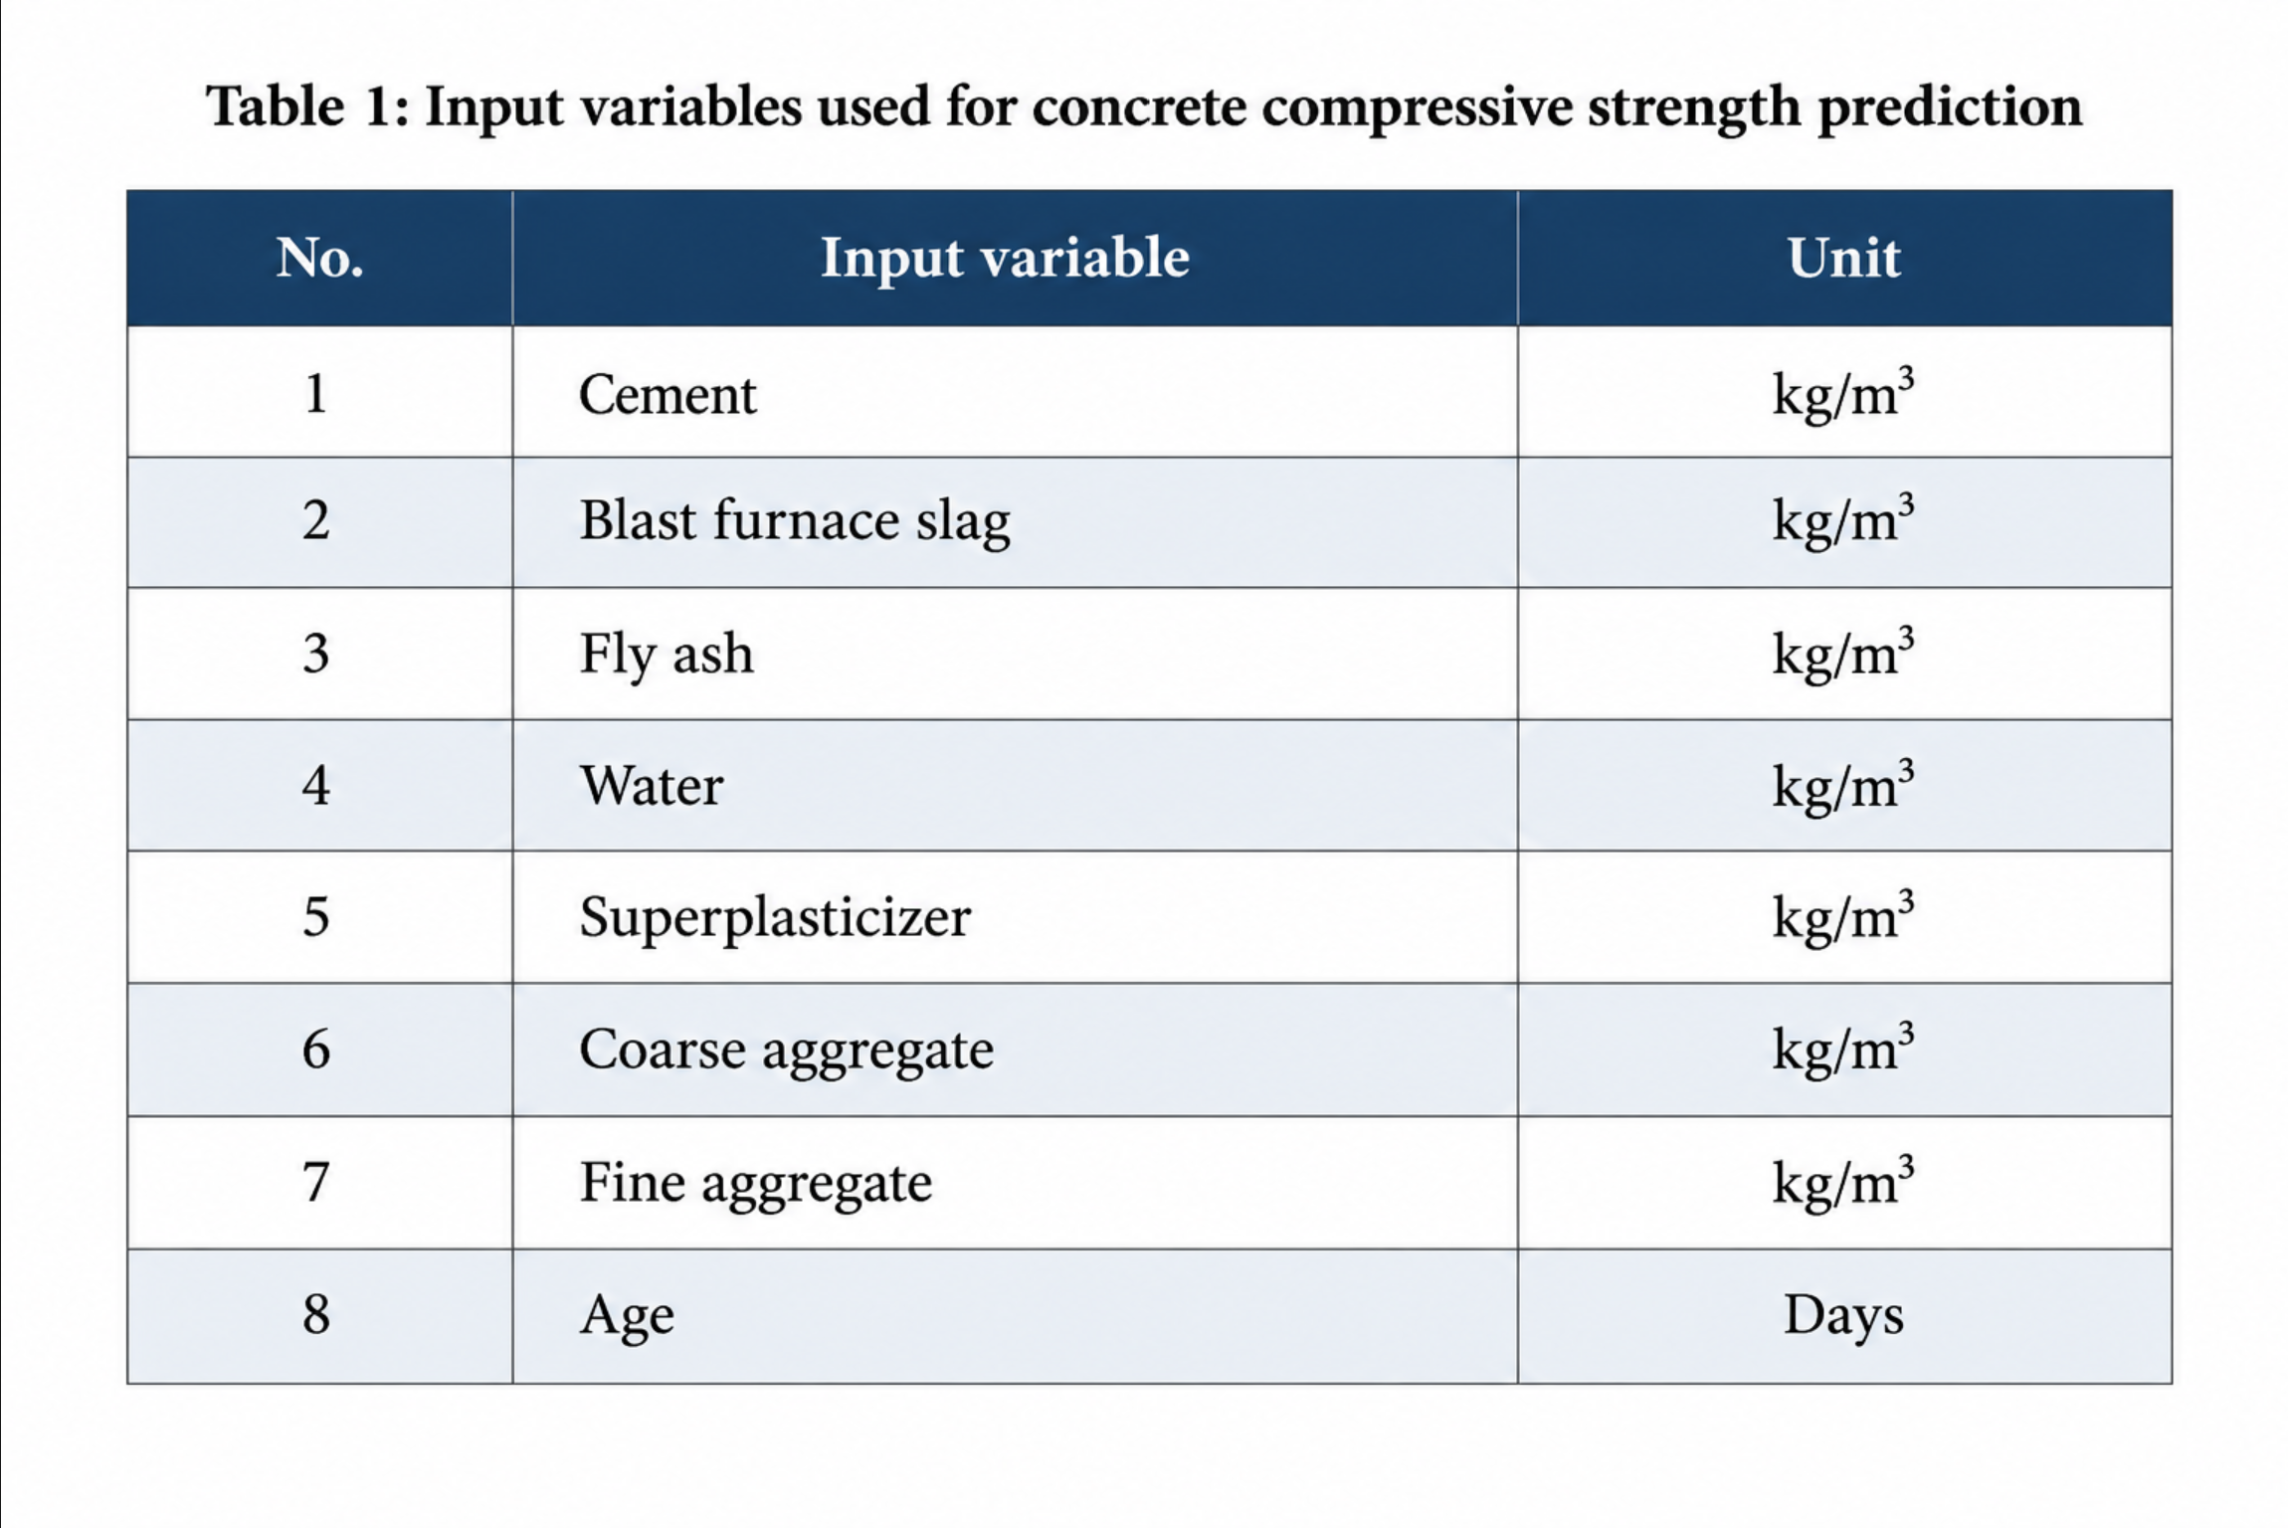
Variables 1-7 represent the quantity of each constituent material per cubic metre of concrete, whereas Variable 8, Age, represents the time elapsed since concrete preparation in days.
The output variable is concrete compressive strength and is measured in MPa. All regression models in this project use the eight inputs to predict compressive strength, this value can then be compared with the experimentally obtained value.
Data Preparation
The dataset was imported into Python using pandas and inspected to identify missing values and confirm its suitability for model development. No missing values were identified, meaning that no observations required removal or imputation.
The eight input variables were separated from the compressive strength output to form the feature matrix (X) and target variable (y), respectively.
To allow independent model development and evaluation, the dataset was divided into three subsets:
- Training set (60%, 618 observations): Used to train the regression models.
- Validation set (20%, 206 observations): Used to evaluate alternative Decision Tree depths and select the preferred model configuration.
- Test set (20%, 206 observations): Reserved for the final evaluation of model performance on unseen data.
A fixed random seed (random_state=42) was used to ensure the data splitting process was reproducible.
Separating the data in this manner reduces the risk of selecting a model based on its performance on the final test dataset. The validation set was used during model optimisation, while the test set provided an independent assessment of the selected model's predictive performance.

Baseline Computational Solution
Selection of Linear Regression
Linear regression was selected as the baseline computational solution due to its simplicity and ease of interpretation, with also very low computational requirements. The method provides a starting point for estimating relationships between the input variables and concrete compressive strength.
Establishing a baseline model allows the effectiveness of more complex regression methods to be assessed through direct comparison. Linear Regression was considered suitable for this purpose because it is straightforward to implement and provides a useful reference for evaluating whether additional model complexity produces meaningful improvements in predictive accuracy.
Mathematical Formulation
Multiple Linear Regression assumes that the predicted concrete compressive strength can be represented as a linear combination of the eight input variables.
The model is expressed as
$$\overset{ˆ}{y}=β_{0}+\sum_{i=1}^{8}{β_{i}}x_{i}$$
Where:
- ŷ = Predicted concrete compressive strength (MPa)
- β₀ = Intercept
- βᵢ = Regression coefficient associated with input variable i
- xᵢ = Value of input variable i
The model coefficients are determined using the ordinary least squares method, which minimises the sum of squared differences between the experimentally measured and predicted compressive strengths.
Model Implementation
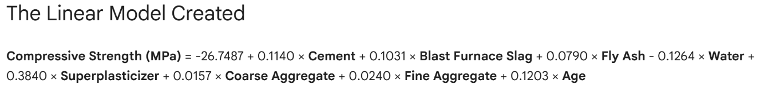
The baseline model was implemented in Python using the ‘LinearRegression’ function from scikit-learn. The model was trained using the 618 observations allocated to the training dataset, with all eight input variables included as predictors. Following training, the model was used to generate compressive strength predictions for unseen observations. These predictions were compared against the experimentally measured values using R², MAE and RMSE.
Limitations
The main limitation of this method is that it assumes a linear relationship between the eight input variables and concrete compressive strength. In practice these relationships may be non-linear combinations of constituents and age.
Due to this, Linear Regression may not capture the complexity of concrete material behaviour and contributions to its strength, potentially limiting its predictive accuracy.
Alternative Solution
Selection of Decision Tree Regression
Decision Tree Regression was selected as an alternative to the baseline due to its ability to capture non-linear relationships between all the input variables and their corresponding compressive strength. It works differently to linear regression as it does not assume a linear relationship between the predictors and output, giving it the ability to identify more complex patterns without requiring a predefined mathematical relationship. The purpose of investigating this method was to determine whether a more flexible modelling approach could improve predictive accuracy in comparison to Linear Regression.
Decision Tree Regression Methodology
Decision Tree Regression operates by recursively dividing the training dataset into smaller groups based on the values of the input variables. At each stage, the algorithm selects a variable and splitting threshold that minimises the prediction error within the resulting groups. This process continues until the specified stopping conditions are reached. Each leaf produces a predicted compressive strength based on the average measured strength of the training observations assigned to that leaf.
The ability to create different prediction regions allows Decision Tree Regression to model nonlinear relationships and interactions between the eight input variables. However, this flexibility introduces a risk of overfitting. If the tree becomes excessively complex, it may capture variations specific to the training dataset rather than relationships that generalise to unseen observations.
Model Implementation
The alternative model was implemented in Python using the ‘DecisionTreeRegressor’ function from scikit-learn. The model was trained using the same 618 observation training dataset subset as the linear regression model. The model was initially trained using the default parameters for the python function, which includes an unrestricted maximum tree depth.
“Max Depth” is a key parameter of Decision Tree Regression which limits the maximum depth of the tree and sets its level of complexity. Following the initial implementation, the Decision Tree's maximum depth was identified as a parameter worth investigating. Without a specified depth limit, the tree can become highly complex and potentially overfit the training data, reducing its ability to generalise to unseen observations.
To investigate this, a sensitivity analysis was subsequently conducted using maximum tree depths ranging from 1 to 20. The preferred depth was selected based on the lowest RMSE on the validation dataset. The optimisation procedure and its impact on predictive performance are discussed later.
Validation
Validation Methodology
Model validation was conducted to assess the ability of both regression approaches to predict concrete compressive strength accurately on previously unseen data. Experimentally measured compressive strength values from the UCI dataset served as the reference values against which model predictions were evaluated. To ensure a consistent comparison, Linear Regression and Decision Tree Regression were trained and evaluated using identical data partitions. As described earlier, the dataset was divided into separate training, validation and test sets. The validation set was used to investigate the effect of Decision Tree depth and select the preferred configuration based on prediction error. This allowed model parameters to be assessed without influencing the final test results.
Following model development and optimisation, predictive performance was assessed using the 206 observations reserved for independent testing. Neither model was fitted using these observations, and the test results were not used to select the Decision Tree depth. Predictions were compared with the corresponding experimental measurements using R², Mean Absolute Error (MAE) and Root Mean Squared Error (RMSE).
Performance Evaluation Metrics
Three statistical performance metrics were used to evaluate the predictive accuracy of the regression models: the Coefficient of Determination (R²), Mean Absolute Error (MAE) and Root Mean Squared Error (RMSE). Together, these metrics provide a comprehensive assessment of model performance by measuring both the ability to explain variation in concrete strength and the magnitude of prediction errors.
Coefficient of Determination (R²) measures the proportion of variation in experimentally measured compressive strength explained by the regression model. A value of 1 indicates perfect predictions, while a value of 0 indicates performance equivalent to predicting the mean observed strength. Negative values indicate performance worse than this baseline.
Mean Absolute Error (MAE) represents the average absolute difference between predicted and experimentally measured compressive strengths. Expressed in MPa, MAE provides an intuitive measure of the typical prediction error, with lower values indicating greater accuracy.
Root Mean Squared Error (RMSE) measures the square root of the average squared prediction error. Also expressed in MPa, RMSE places greater emphasis on larger errors, making it particularly useful for identifying models that produce substantial deviations from experimental measurements.

Validation and Testing Results
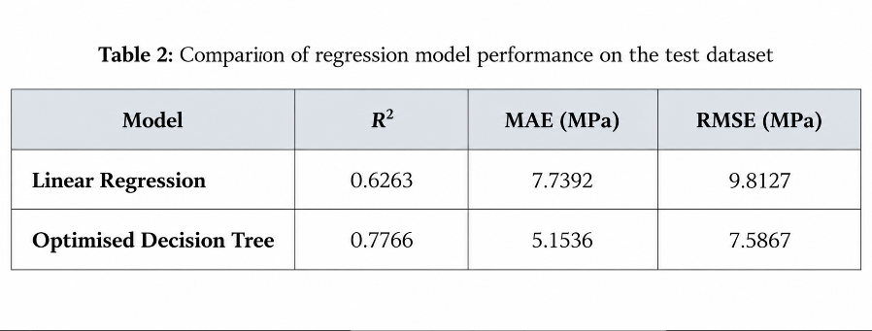
The predictive performance of Linear Regression and the optimised Decision Tree Regression model was evaluated using the independent test dataset. The results obtained for each performance metric are presented in Table 2.

The Linear Regression model achieved an R² of 0.6263, indicating that it explained approximately 62.6% of the variation in concrete compressive strength within the test dataset. However, the MAE of 7.7392 MPa and RMSE of 9.8127 MPa indicate that considerable prediction errors remained, suggesting that the linear model was unable to fully capture the relationships between concrete mixture composition, curing age and compressive strength.
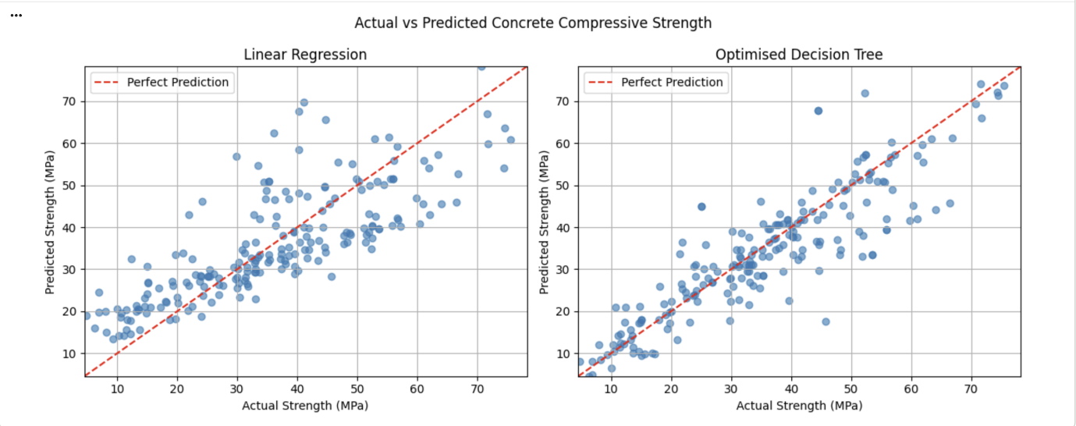
In comparison, the optimised Decision Tree achieved an R² of 0.7766, alongside lower MAE and RMSE values of 5.1536 MPa and 7.5867 MPa, respectively. These results indicate that the Decision Tree provided more accurate predictions on unseen observations, supporting the use of a nonlinear modelling approach for this application. The predictive performance of both models was also examined visually using actual-versus-predicted compressive strength plots, presented in Figure 1.
Figure 1. Actual v Predicted Strength both Models
The plots provide a visual comparison of prediction accuracy, with points closer to the diagonal reference line indicating stronger agreement between predicted and experimentally measured compressive strengths. The Decision Tree results exhibit better overall agreement with the experimental measurements, consistent with the improvements observed in the numerical evaluation metrics.
Validation and Testing Limitations
Although both models were evaluated using an independent test dataset, their predictive performance remains dependent on the characteristics of the available experimental observations. The test results demonstrate how accurately the models predict concrete compressive strength for unseen observations drawn from the same dataset, but do not guarantee equivalent performance for substantially different concrete mixtures or curing conditions. Furthermore, the evaluation was conducted using a single random division of the dataset rather than repeated testing or cross-validation. Consequently, the reported results may be influenced by the observations included in each subset. Therefore, the models should be considered preliminary prediction tools rather than replacements for experimental strength testing.
Optimisation
Decision Tree Depth Analysis
Following the initial implementation of Decision Tree Regression using the default parameters, a sensitivity analysis was conducted to investigate the influence of maximum tree depth on predictive performance. The max_depth parameter controls the maximum number of levels within the Decision Tree, directly influencing model complexity. A shallow tree may be unable to capture important relationships between concrete mixture composition, curing age and compressive strength, resulting in underfitting. Conversely, an excessively deep tree may fit the training observations too closely, reducing its ability to generalise to unseen data.
To identify a suitable configuration, Decision Tree models were trained using maximum depths ranging from 1 to 20. Each configuration was evaluated using RMSE on both the training and validation datasets. The results of the sensitivity analysis can be seen in Figure 2.
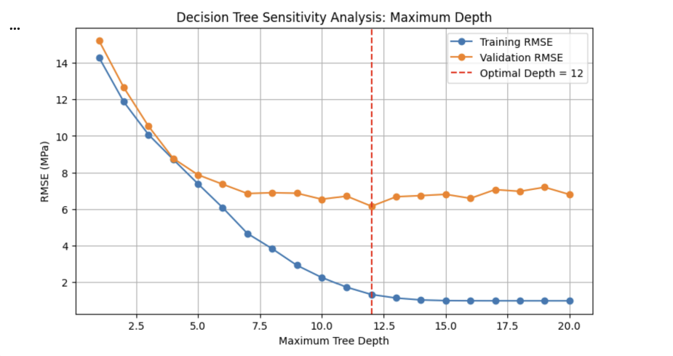
Figure 2. Effect of Decision Tree Depth on RMSE

The sensitivity analysis demonstrated the importance of controlling Decision Tree complexity to balance predictive accuracy and generalisation. Increasing tree depth allows the model to represent more complex relationships within the training data. However, improvements in training accuracy do not necessarily translate into better predictions on unseen observations. The lowest validation RMSE of 6.1469 MPa was achieved at a maximum tree depth of 12. This configuration was therefore selected as the optimised Decision Tree model. Importantly, the preferred depth was determined using the validation dataset rather than the independent test dataset. This ensured that the final test observations remained separate from the optimisation process.
Following optimisation, the selected Decision Tree model was evaluated using the independent test dataset and compared against the Linear Regression baseline. As presented in Table 2, the optimised Decision Tree achieved a test RMSE of 7.5867 MPa, compared with 9.8127 MPa for Linear Regression. This represents a 22.7% reduction in RMSE, indicating an improvement in predictive accuracy. Similarly, MAE decreased from 7.7392 MPa to 5.1536 MPa, representing a 33.4% reduction in average absolute prediction error. The coefficient of determination also increased from 0.6263 to 0.7766.
These improvements suggest that Decision Tree Regression was better suited to capturing the complex relationships between concrete mixture composition, curing age and compressive strength than the linear baseline. However, this improvement comes with increased model complexity and a greater sensitivity to training data. Furthermore, the results demonstrate an improvement over Linear Regression rather than proving that the selected Decision Tree is the best possible prediction method. Overall, the optimisation process demonstrated how adjusting model complexity using independent validation data can improve predictive performance while limiting the risk of overfitting.
Computational Runtime
Computational efficiency was assessed by comparing the training and prediction times of Linear Regression and the optimised Decision Tree model. Measurements were conducted in Google Colab using Python's time.perf_counter() function, with each operation repeated 100 times and the median execution time recorded to minimise timing fluctuations.

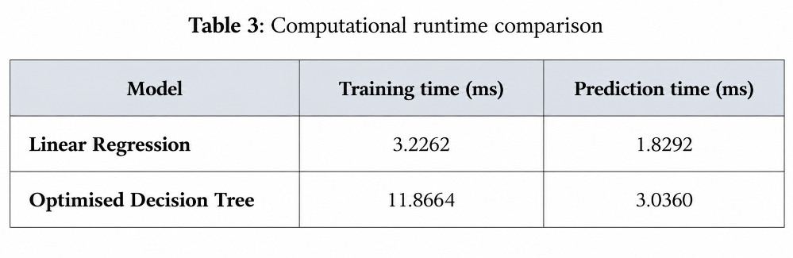

Linear Regression demonstrated greater computational efficiency, requiring 3.2262 ms for training and 1.8292 ms for prediction. In comparison, the optimised Decision Tree required 11.8664 ms and 3.0360 ms, respectively. Consequently, the Decision Tree took approximately 3.68 times longer to train and 1.66 times longer to generate predictions. Despite its higher computational cost, the Decision Tree achieved a 22.7% reduction in test RMSE compared with Linear Regression. Given that both models completed training and prediction within milliseconds, the additional computational time was considered acceptable for the improved predictive accuracy.
These findings support the selection of the optimised Decision Tree for predicting concrete compressive strength, while highlighting the trade-off between computational efficiency and predictive performance.
AI Use and Reflection
I utilised ChatGPT to assist in structuring and writing the code in my Google Colab Notebook. As I am not proficient in python, I relied heavily on AI to write code for me. Throughout the process of creating the Colab file, I would tell AI what I wanted the code to do, then I would check this code and run it and check the outputs. This was always done in small sections with only one cell of code done at a time ensuring I always checked them and understood what was being done. Where I wasn’t sure of certain things in the code I always asked AI to explain to me for example the scikit-learn function. I would say AI contributed to about 90% of the code written in the Colab notebook.
I ran into some problems with the code and learnt that AI isn’t always correct. Some things wouldn’t run as they should and troubleshooting had to take place to rectify these things. My overall understanding of python has been greatly improved by AI as I explicitly asked it to explain all code that it was giving to me and I always ensure to read this before adding it.
AI was used less extensively with the report. I used AI to help structure certain paragraphs and create a few figures. AI was also very helpful in doing calculations included in the report on some of the performance metrics, as it had full access to my code and outputs. If I had to put a number on it I would say AI approximately contributed to about 30% of the report. I also learnt that AI can really struggle to fully address what is actually relevant in terms of the brief sometimes. I found in some situations where I asked for some suggestions on points to discuss many of the outputs it provided were quite irrelevant.
I also used AI to format my references.
References
Yeh, I.-C. (1998a). Concrete compressive strength [Data set]. UCI Machine Learning Repository. https://doi.org/10.24432/C5PK67
Yeh, I.-C. (1998b). Modeling of strength of high-performance concrete using artificial neural networks. Cement and Concrete Research, 28(12), 1797–1808. https://doi.org/10.1016/S0008-8846(98)00165-3

